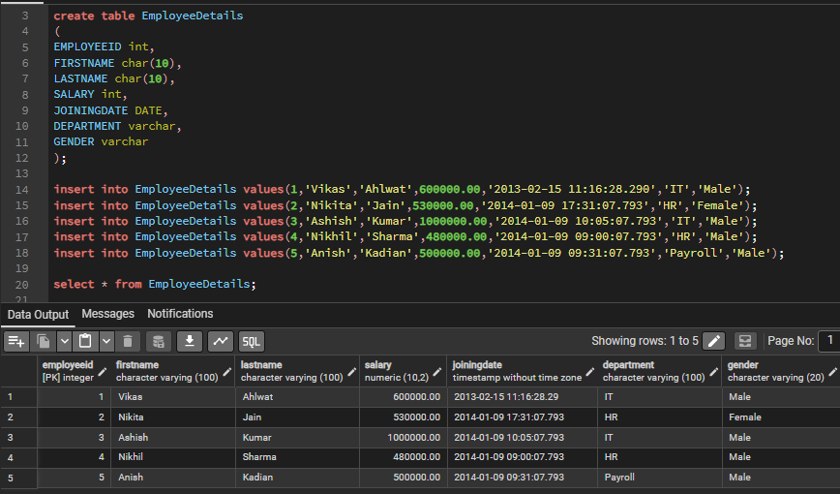
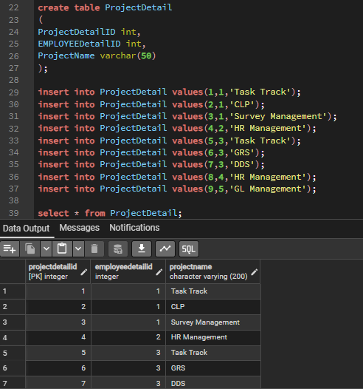

1. Write the query to get the department and department wise total(sum) salary from "EmployeeDetails" table?
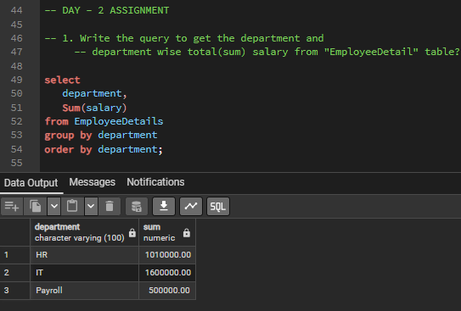
2. Write the query to get the department and department wise total(sum) salary, display it in ascending order according to salary?
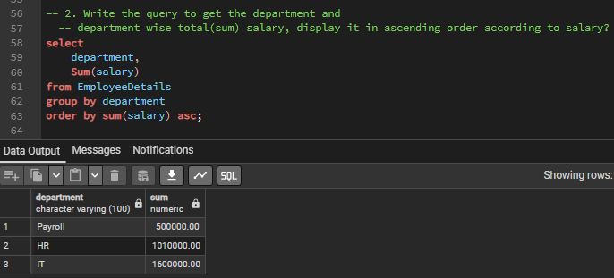

3. Write the query to create a primary and foreign key relationship for the above mentioned tables?
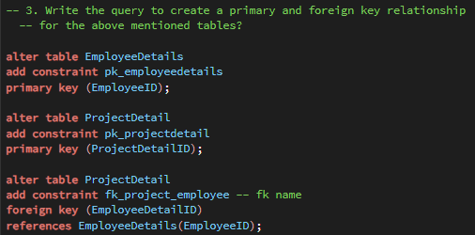

4. Write the query to get the department and department wise total(sum) salary, display it in descending order according to salary?
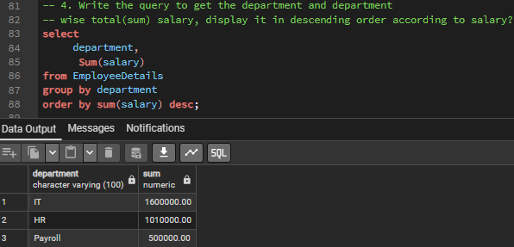

5. Write the query to get the department, total no.of.departments, total(sum) salary with respect to department from "EmployeeDetails" table?
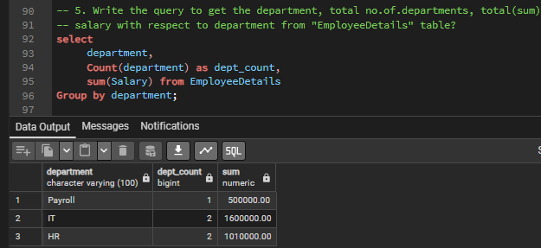

6. Write the query to get department wise average salary as well max salary from given table order by salary ascending
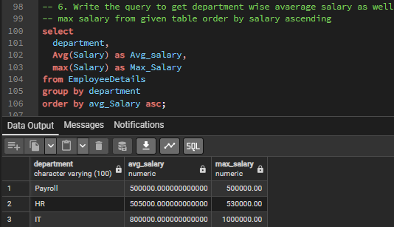

7. Write the query and apply all the constraints such on PK, FK
a. Not NULL, Unique, Check and Default on EmployeeDetails table
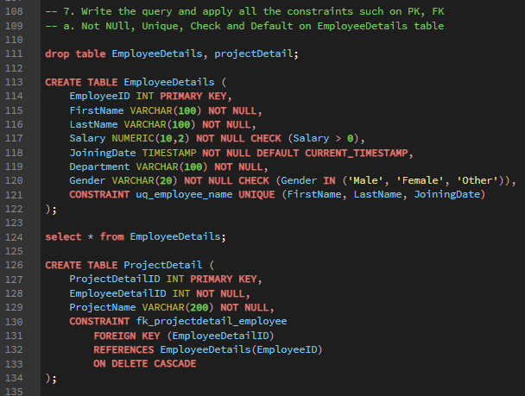

8. Write down the query to fetch Project name assign to more than one employee
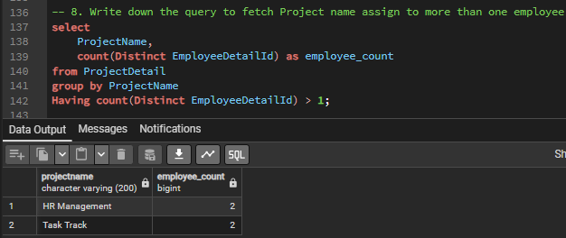

9. Write down the query for rollup and cube commands on Employeedetails table
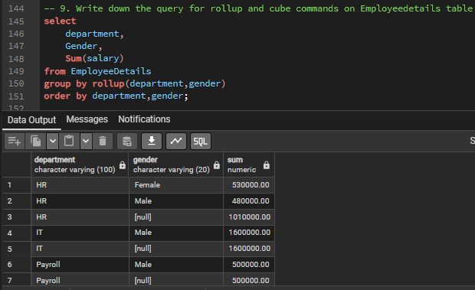
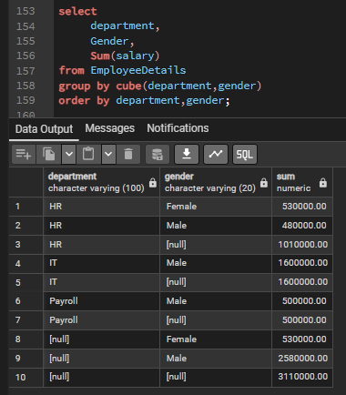

10. Write down the query to fetch the rows only top 5 from EmployeeDetails
